FEST MANAGEMENT SYSTEM

Phodkar Parth Prashant Priyanka

Department of Electronics Engineering Shah and Anchor Kutchhi Engineering College, Mumbai 400088, India parth.phodkar_19@sakec.ac.in

Arakade Aditya Vijay Chhaya

Department of Electronics Engineering Shah and Anchor Kutchhi Engineering College, Mumbai 400088, India aditya.arakade_19@sakec.ac.in

Patil Vedant Bhausaheb Jayashri

Department of Electronics Engineering Shah and Anchor Kutchhi Engineering College, Mumbai 400088, India vedant.patil_19@sakec.ac.in

Sawant Sarvesh Shashikant Smruti

Department of Electronics Engineering Shah and Anchor Kutchhi Engineering College, Mumbai 400088, India

sarvesh.sawant_19@sakec.ac.in

Dr. Sarika Bukkawar

Department of Electronics Engineering Shah and Anchor Kutchhi Engineering College, Mumbai 400088, India

sarika.bukkawar@sakec.ac.in

***Abstract****—* Fest management system will allow college authorities to streamline events processes and manage students with ease and provide unified environment for enjoyment. This project includes registration system implemented using SQL. Database is nothing but an organized collection of data stored electronically and SQL is a domain specific language used in programming and for managing data which is held in a relational database management system or for stream processing in a relational data stream management system.

***Keywords—*** DBMS, SQL, HTML, CSS, PHP, XAMPP, Bootstrap.

**I. INTRODUCTION**

In this project a website has been created with the help of HTML, CSS and PHP which would help a student to register for the events of the college fest. In this website students are supposed to register their basic details after which a participation ID is generated. The participation ID can be used to extract the details of the students and the student will be accepted or exempted from the event based on requirements which are supposed to be met. The database created would be helpful to keep a track of the students that have registered for various events of the fest.

1. **SOFTWARE**
2. ***Xampp***

XAMPP is a free and open-source cross-platform web server solution stack package developed by Apache Friends, consisting mainly of the Apache HTTP Server, MariaDB database, and interpreters for scripts written in the PHP and Perl programming languages. Since most actual web server deployments use the same components as XAMPP, it makes transitioning from a local test server to a live server possible. XAMPP's ease of deployment means a WAMP or LAMP stack can be installed quickly and simply on an operating system by a developer, with the advantage that common add-in applications such as WordPress and Joomla! can also be installed with similar ease using Bitnami.

1. **ER DIAGRAM**

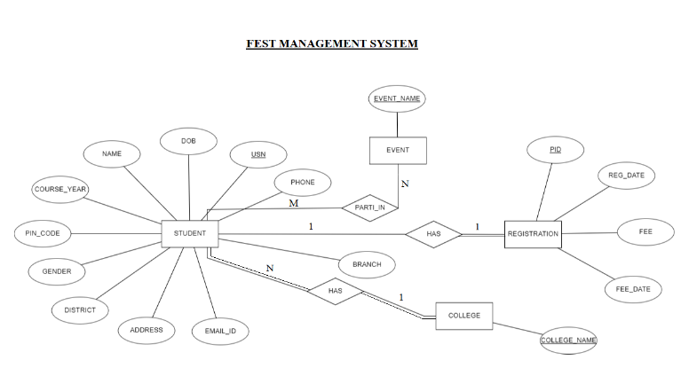

Fig. ER Diagram

The ER diagram consists of four entities and all these entities are strong entities. The entities are as follows: College, Student, Registration and Event. The College entity has an attribute College_Name and it is the primary key of the College entity. The student entity has the following attributes: USN which is the primary key, Name, Gender, Phone, Email-Id, DOB, Branch, Course_Year, Address, District and Pin_Code. The Registration entity has the following attributes: Pid which is the primary key, Reg_Date, Fee and Fee_Date.

The Event entity has an attribute Event_Name and it is the primary key. The College entity has a relationship with the Student entity i.e one college has many students, therefore their cardinality ratio is 1:N and both the entities has total participation. The student entity has a relationship with the Registration entity such that one student has to register only once, therefore their cardinality ratio is 1:1. Since all the students of the college may not register for the events, so the student entity has partial participation. For the registration entity all the registered students will get the PID therefore it has total participation. The Student entity has a relationship with the Event entity such that many students can participate in many events therefore their cardinality ratio is M:N and both of the entities have partial participation.

**IV. MAPPING OF ER SCHEMA**

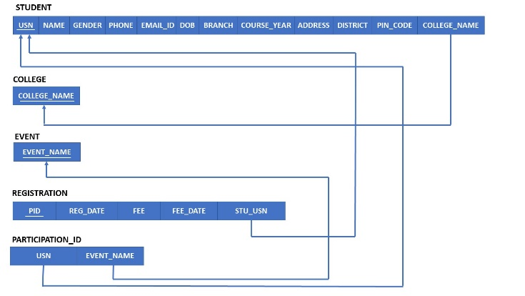

In Relational Database Management System, we have to store all the data in the form of a Table. So, we Map ER diagram into tables. Tables are formed in view that there must not be any redundancy of data. Where redundancy of data is nothing but repetition of same columns in tables or in other words duplication of data. Duplication of data is avoided as it increases storage space of database and also increases the computational power/time of any query. The first step in mapping an ER diagram into a table is making a separate table for each of the strong entities. The strong entities in the ER diagram are Student, Event, Registration and College. So, a separate table has been created for each of these strong entities. In the Student table, the attributes USN, name, gender, phone, email id, date of birth, branch, course year, address, district, pin code, and college are as included. The USN or username, which is the primary key of the Student entity is also included as an attribute in two more tables viz. in the Registration table and the Participation ID table. This is due to the binary 1:1 relation between the Student and Registration entities. As the Student table has partial participation, the primary key of the Student table i.e. the username is included as an attribute in the Registration table, which actually has total participation. This makes the USN of Student entity a foreign key in Registration and Participation ID tables. The Student table also has a foreign key which is college name from the College table. The College table has the attribute college name which is also the primary key of the College entity, is included as an attribute in the Student table, which makes it a foreign key in the Student table. This is also due to the Binary 1:N relation between the College and Student entities. The Student and the Event tables have Binary M:N relation. As a result, a separate table has been created named participation ID. The Event table has the attribute event name which is also the primary key of the same entity is included as attribute in the Participation ID table as a foreign key. While the Participation ID table has another foreign key which is username from the student entity. The registration table has the attributes PID, registration date, fee and fee date and another attribute of USN as a foreign key from the student table. To indicate which primary key of an entity is included in what entity as a foreign key, these arrows are used.

**V. WORKING**

Our project works on a local web server created using Xampp. The database is created in phpMyAdmin. Also the website is created in php, html, and basic css using bootstrap and phpMyAdmin. In our website there is a home page where there is our college and fest information. Then on the navigation bar there are two buttons of Registration and Registered students. By clicking on registration we are taken to a form page which can also be accessed from individual event cards. In the form students have to enter all their details, select event and mention paid fee, fee date, registration date etc. After submitting a “successful entry in database” page is shown with brief of entered details, below which there is a show PID (Participation Id) button which shows us our PID, which is used to part-take in fest events. Database is interfaced with our website using mysql_connect() function, after which connection is checked and if successful then data from the form after submitting is entered into the database. Now the Registered students button takes us to a page where we can see list of details of all the students participating in events and total fees collected. This is done by creating a view in the database and a sum function to calculate the total fees.

**VI. WEBSITE PAGES**

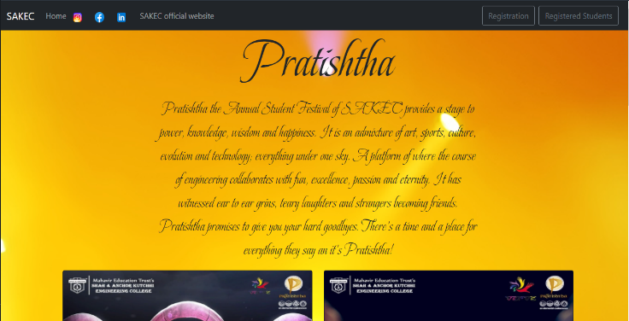

Home page

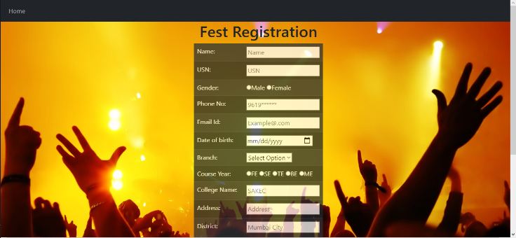

Registration Page

**VII. FUTURE DEVELOPMENTS**

1. Payment Gateway can be created.
2. For additional security Sign in/admin feature can be added.
3. Users can edit their registration form details.

**VIII. REFERENCES**

1. https://getbootstrap.com/docs/5.1/getting-started/introduction/
2. https://www.youtube.com/watch?v=w37iooYWi90&list=PLK5n0g9qiF3c5b3yi4FJwib8IN-Br032b&index=6
3. https://www.w3schools.com/sql/
4. https://www.shahandanchor.com/home/
5. https://www.shahandanchor.com/pratishtha/